Protect our most precious resource.
Invest in our water future.

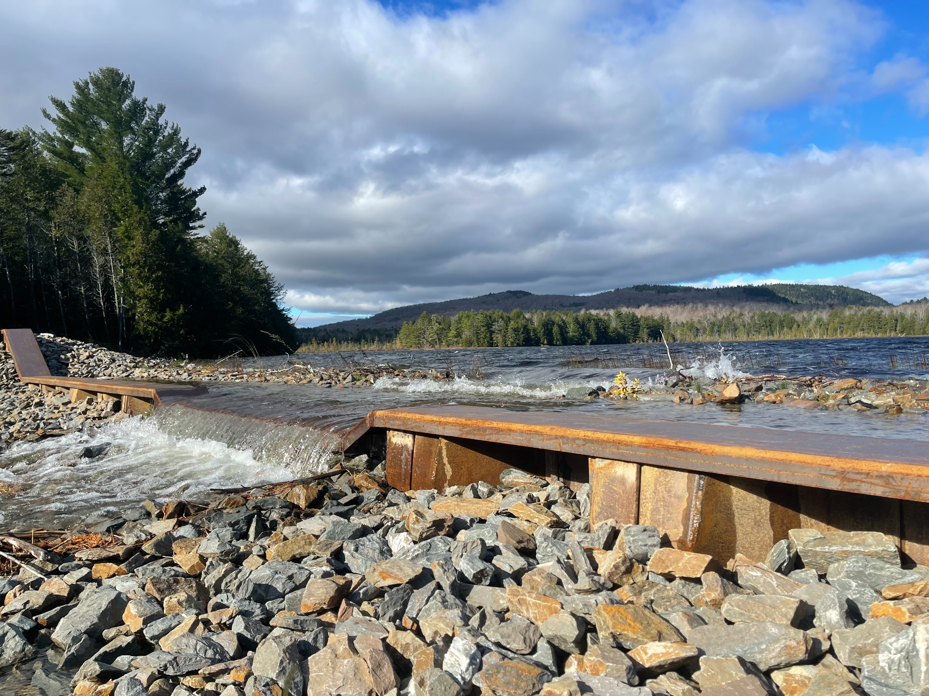
Vote Yes to allow Dover & Foxcroft Water District to raise its debt limit for needed infrastructure improvements

Why this matters to You

Your water district is asking for your support to increase its debt limit.
This is not going to raise your rates.
The district has already raised rates and has the funding to pay for planned projects over time with low interest loans and bonds.
- Construction costs have gone up drastically, making it necessary to increase our borrowing limit.
- Without long-term borrowing the district will need to fund projects directly through rates, which means unpredictable increases in individual bills as projects arise.

Did you know?

- The water mains the District is planning to replace are over 100 years old.
- The risk of costly main breaks is rising.
- We must meet evolving water quality standards.
- This is not a vote to increase customer bills.
- Without the increase of the Districts debt limit, we may lose $1,000,000 in grant funding awarded to the District in 2025.

The Problem We Face
Our current debt limit of $3.5 million no longer matches the scope of our infrastructure needs. Without an increase to $5.5 million, we will face two paths:

Path 1: Inadequate maintenance → Deferred projects, higher risk of emergencies.
Path 2: Significant rate hikes → Paying with cash reserves, sudden burden on customers.

The Smart Solution:
By raising the debt limit now, we can access low-interest financing like municipal bonds. This keeps rates stable while investing in long-term system health.

Your Investment in a Stronger Community
A 'Yes' vote is an investment in:
Public Health: Safer, cleaner water supply.
Reliable Service: Prevent interruptions.
Property Values: Protect and grow
community value.
Future Generations: Prevent costly, crumbling infrastructure.

We have developed a multi-year Capital Improvement Plan (CIP), guided by engineers and financial advisors.
See details at https://doverfoxcroftwater.org.

How to Vote YES
Vote on November 4th, 2025 8AM to 8PM.
Need more information?
- Visit: https://doverfoxcroftwater.org
- Community Meeting: Oct 14th, 2025 at 6:00 PM (48 Morton Ave, Suite B)
- Read the full CIP online
- Call: 207-564-2310
- Email: customerservice.dfwater@gmail.com

Please Vote “YES”
to secure our water future!

